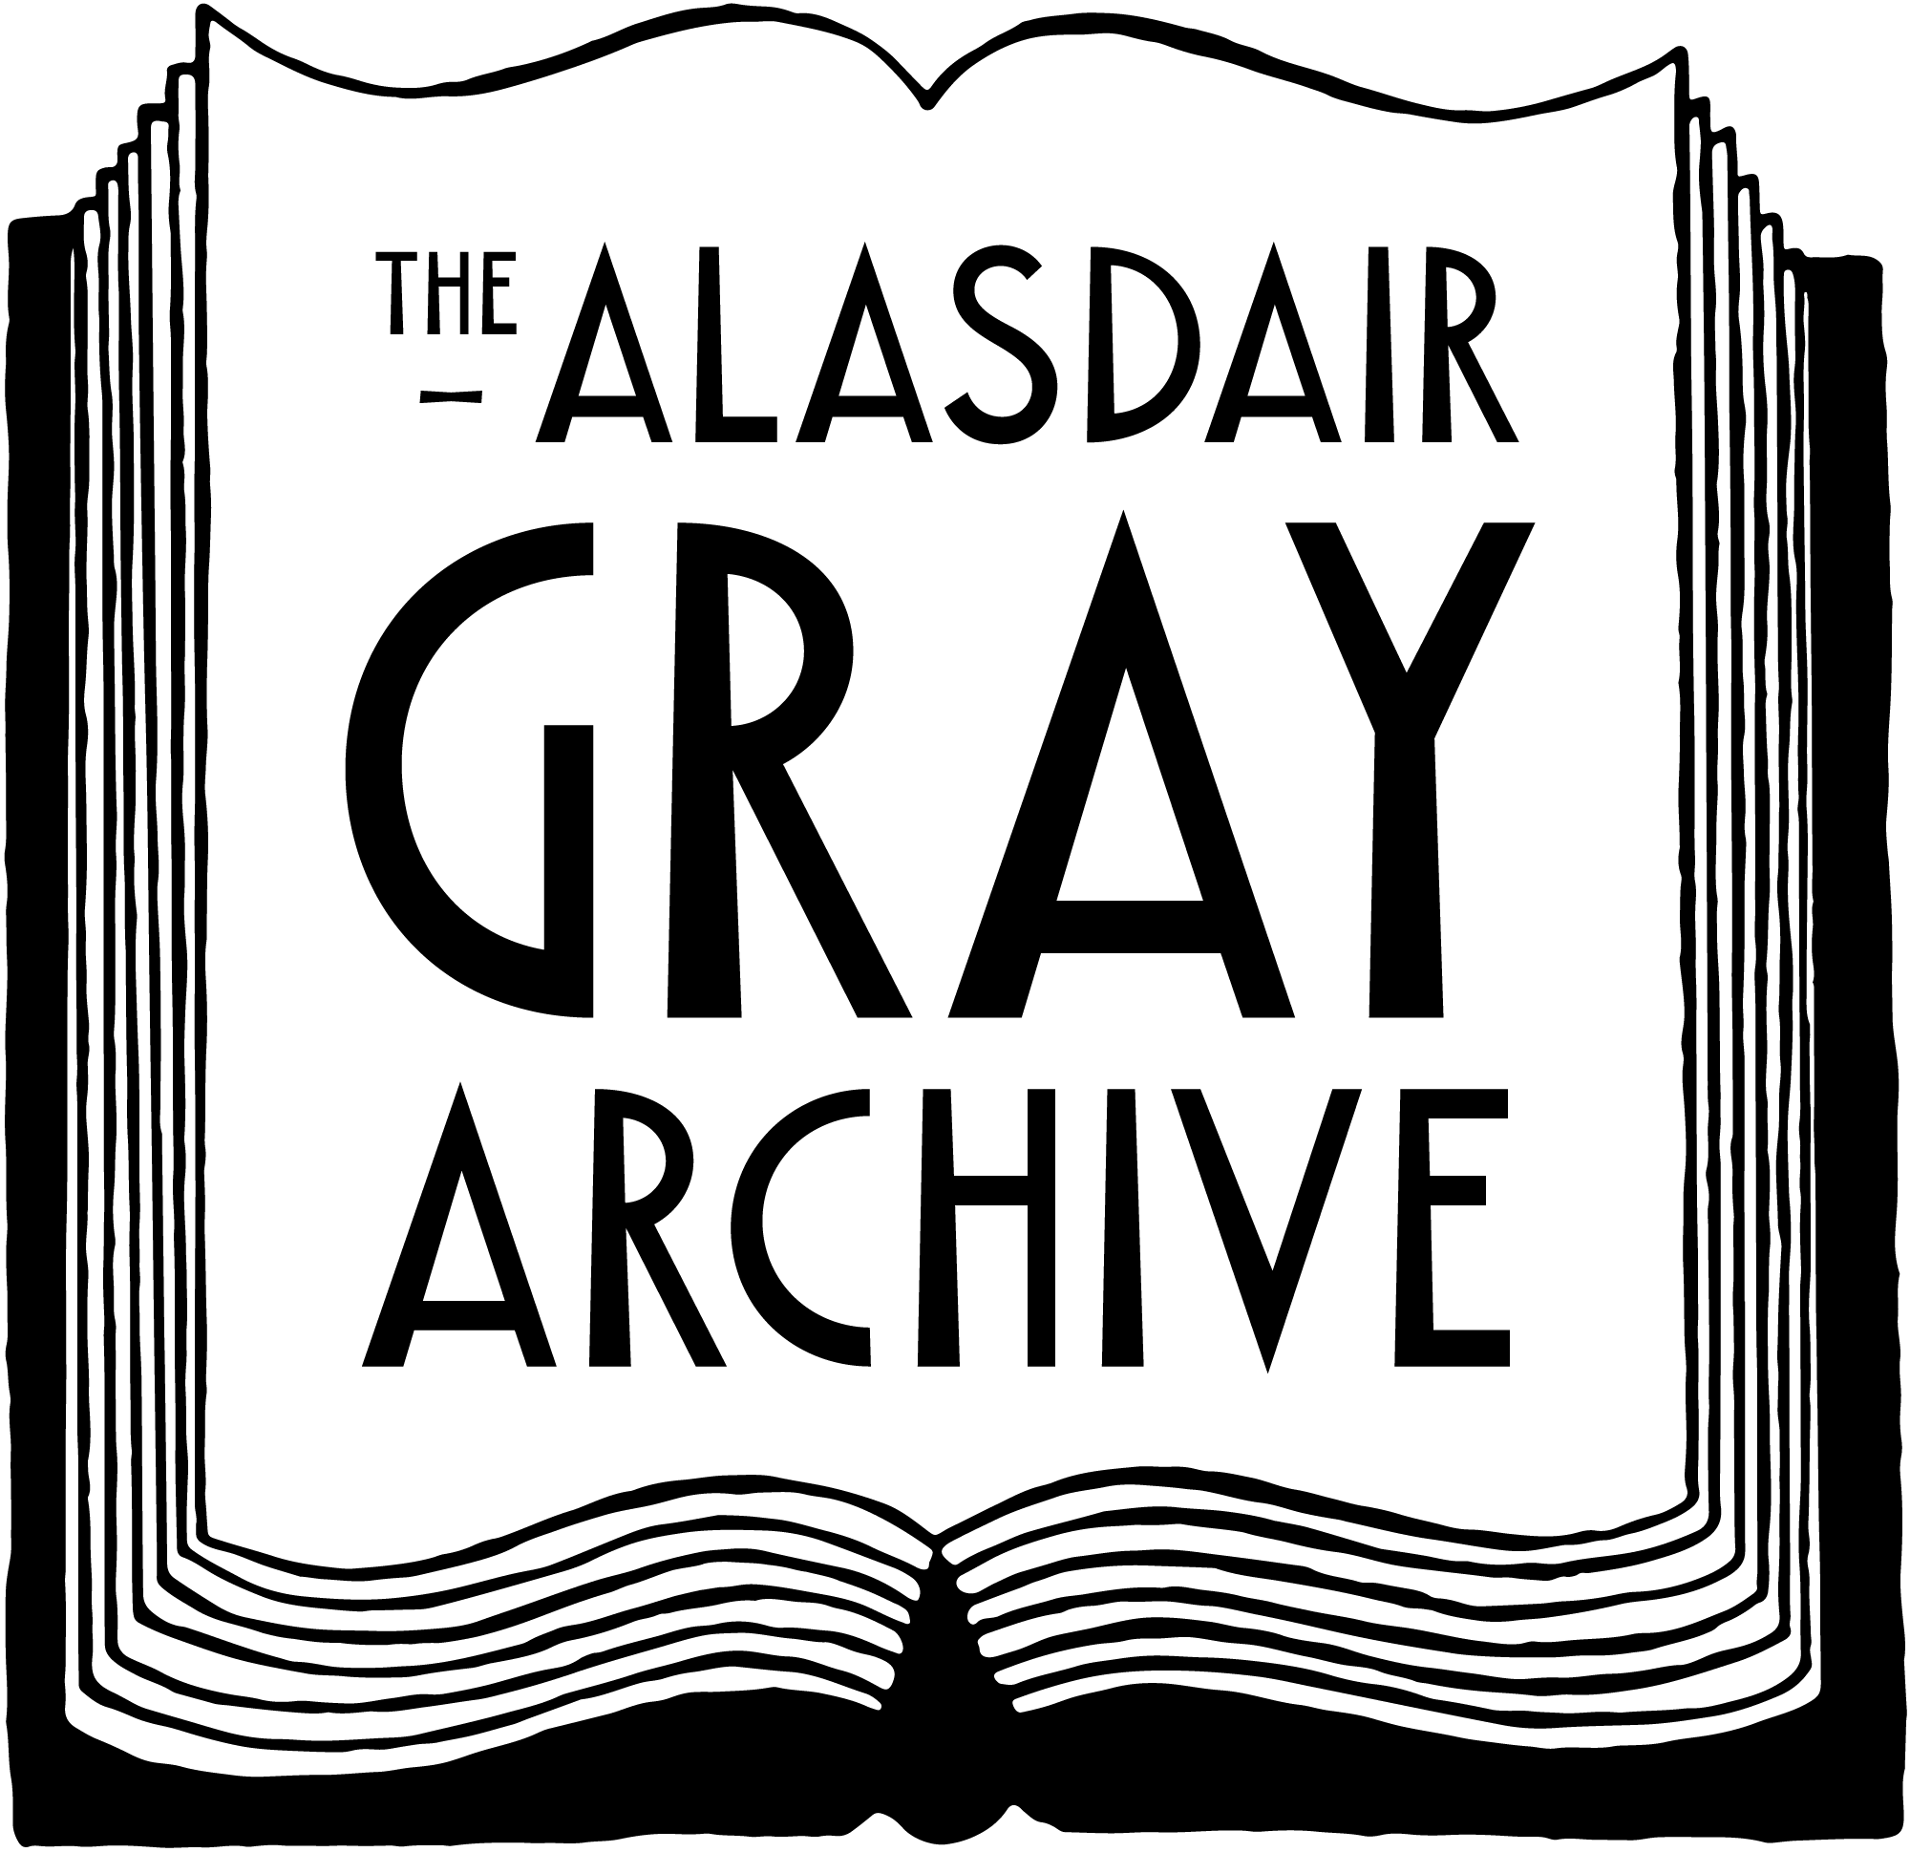

The Alasdair Gray Archive Fair Work Statement

1. Overview
Agreed by the Board, this statement confirms the Alasdair Gray Archive’s commitment to ensuring fair working practices are in place in support of ‘Fair Work First’ in the development of our programming and activities in relation to both staff and work with other creatives, contractors and freelancers.
The principles of fair work are:
- Fair Opportunity
- Security of income
- Fulfilment
- Respect at work
- Effective Voice

2. Context
Fair Work First is the Scottish Government's flagship policy for driving high quality and fair work across the labour market in Scotland by applying fair work criteria to grants, other funding and contracts being awarded by and across the public sector, where it is relevant to do so. Through this approach, the Alasdair Gray Archive will adopt fair working practices, specifically:
- Payment of at least the real Living Wage
- Providing appropriate channels for effective workers’ voice
- Investment in workforce development
- No inappropriate use of zero hour contracts
- Positive action in relation to the gender pay gap and creating more diverse and inclusive workplace
- Offer flexible and inclusive working practices for all workers
- Opposing the use of fire and rehire practices

3. Values
The AGA values and the priorities of the AGA vision and strategy are in alignment with the Fair Work First principles, further demonstrated by the following:
- The Alasdair Gray Archive is a Living Wage employer, and is working towards accreditation for inclusion on the living wage website https://scottishlivingwage.org/employer-directory/
- In addition to a culture of partnership and collaboration, the AGA Board encourages informal routes for engagement in line with the values of the organisation, which can be found on the website at https://thealasdairgrayarchive.org/about/
- The significance of organisational development is highlighted within the strategy and the Archive is committed to investing in our organisational capability and the experiences and opportunities that this presents our workforce
- The AGA Workforce Statement is clear that zero hour contracts do not meet the principles of the policy and that they will only be mutually appropriate in some limited circumstances
- The Archive works to go beyond the statutory obligations, including with day one entitlements
- The Archive does not engage in ‘fire and rehire’ practices.

The Alasdair Gray Archive Unit 5.07
The Whisky Bond, 2 Dawson Road, G4 9SS
Tel: 07812605745 sorcha@thealasdairgrayarchive.org

